**PRAYERHOUSE HOLINESS CHURCH AUDIO/VISUAL DEPARTMENT PRICELIST**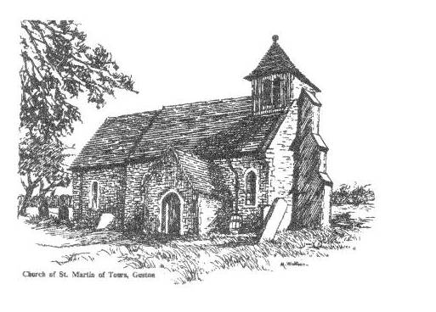

***DVD RECORDING $5.00 (EA)***

***CD RECORDING $5.00 (EA)***

***DVD/CD RECORDING $10.00 (EA)***

***CONTACT:***

***MIN. JONES***

***DECON. PROCTOR***